

**Year 11**

**PSYCHOLOGY ATAR 2021**

**TASK 1 – Biological Influences**

**(Weighting: 5%)**

Time allowed: 60 minutes

Name: ____________________________________

|  |  |
| --- | --- |
| MARKS AVAILABLE | YOUR MARK |
| 59 |  |
|  | % |

**Question 1 [5 marks]**

Label the following diagram of a brain.

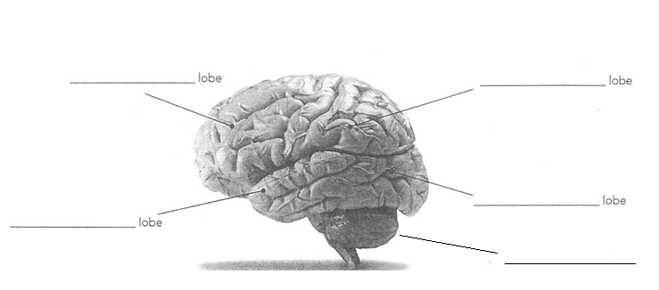

**Question 2 [4 marks]**

A person has a brain injury and starts to lose fine motor coordination of his muscles and walks as if he is drunk. He also finds it difficult to speak. Name the two parts of the brain that have been affected by the injury and explain your choices.

________________________________________________________________________________________________________________________________________________________________________________________________________________________________________________________________________________________________________________________________________

**Question 3 [6 marks]**

The forebrain is made up of three (3) main components.

1. Name the three components:

____________________________________________________________________________________________________________________________________________________________________________________________________________________________________

1. State three (3) functions of the forebrain.

____________________________________________________________________________________________________________________________________________________________________________________________________________________________________

**Question 4 [8 marks]**

1. Identify the structure of a neuron shown by the labels in the illustration below. (3 marks)

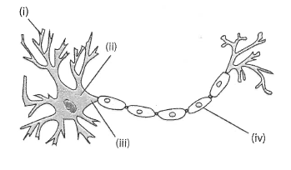

Structure of a neuron

1. ______________________________________________________________
2. ______________________________________________________________

(iv) ______________________________________________________________

1. Describe the purpose of the structure labelled at (iv) in part (a). (1 mark)

____________________________________________________________________

____________________________________________________________________

1. Label (iii) is the axon. Describe the function of the axon. (2 marks)

____________________________________________________________________

____________________________________________________________________

1. Draw an ARROW to show the direction of the impulse along this neuron. (1 mark)
2. What type of neuron does this diagram depict? (1 mark)

______________________________________________________________________

**Question 5 [7 marks]**

Label the following diagram. (3 marks)

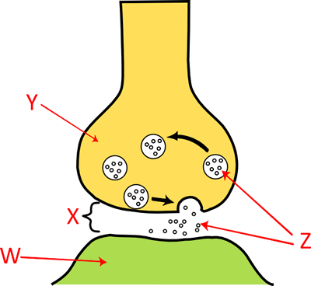

X __________________________________

Y__________________________________

Z ___________________________________

b. Name ONE neurotransmitter that could be released from a vesicle in the brain. (1 mark)

______________________________________________________________________

c. Briefly explain how the neurotransmitter allows communication of an impulse to be transferred from one neuron to another. (3 marks)

________________________________________________________________________________________________________________________________________________________________________________________________________________________________________________________________________________________________________________________________________________________________________________________________________________

**Question 6 [6 marks]**

Drugs can have many effects on the nervous system and therefore on the psychological and physiological functions of the body.

Describe ONE psychological effect and ONE physiological effect on the body of the following drug types, AND give ONE example of each.

1. Stimulant: ____________________________________________________________________________________________________________________________________________________________________________________________________________________________________
2. Depressant: __________________________________________________________________________________________________________________________________________________________________________________________________________________________________

**Question 7 [8 marks]**

Researchers use various types of technology that assist them to understand the brain.

1. Describe the function and purpose of using an EEG (electroencephalography) to investigate brain activity. (3 marks)

_____________________________________________________________________________

_____________________________________________________________________________

_____________________________________________________________________________

1. What does MRI mean? _______________________________________________________

(1 mark)

c) Describe the difference between MRI scans and PET scans. (4 marks)

_____________________________________________________________________________

_____________________________________________________________________________

_____________________________________________________________________________

_____________________________________________________________________________

_____________________________________________________________________________

_____________________________________________________________________________

**Question 8 [3 marks]**

Many studies show that exercise has many physical and psychological benefits.

Explain THREE possible reasons for these positive effects.

____________________________________________________________________________________________________________________________________________________________________________________________________________________________________________________________________________________________________________________________________________________________________________________________________________________________________________________________________________________________________________

**Question 9 [12 marks]**

Split brain studies have been used to explain how the left and right hemispheres function.

1. Name the researcher who is associated with the original key research using split brain patients.

(1 mark)

____________________________________________________________________________

1. List FOUR (4) functions of the left hemisphere of the brain. (4 marks)

____________________________________________________________________________________________________________________________________________________________________________________________________________________________________________________________________________________________________________________________

1. Name the collection of white myelinated nerve fibres that joins the two hemispheres of the cerebrum, and state the function of this structure. (2 marks)

_____________________________________________________________________________________________________________________________________________________________________________________________________________________________________________

1. What did the researcher conclude about visual information processing in split brain patients, and explain how he reached this conclusion? (5 marks)

________________________________________________________________________________________________________________________________________________________________________________________________________________________________________________________________________________________________________________________________________________________________________________________________________________________________________________________________________________________________________________________________________________________________________________________________________________________________